Worksheet 7.5

Slowing global
warming — alternatives
Student: Class:

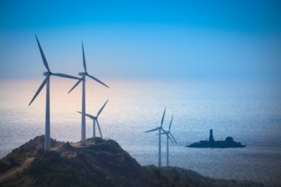
Wind power
The wind is free and blows almost continuously; a series of wind turbines can supply a viable and reliable source of energy. It has the added advantage of being non-polluting. However, there has been controversy as wind farms can be quite noisy and some people think they spoil the aesthetics of the natural environment.

Photo: chuyu / 123RF

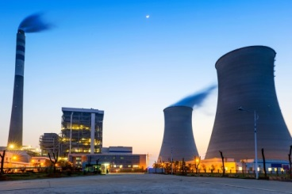
Nuclear power
Australia has vast reserves of uranium, the essential element required to produce nuclear power. Enormous amounts of energy can be harnessed through nuclear power generation, but the risks are also great. Waste products and spent nuclear rods remain radioactive for thousands of years, and if a reactor goes into ‘meltdown’ or these waste materials leak into the environment, the results could be devastating.
Photo: hxdyl / 123RF

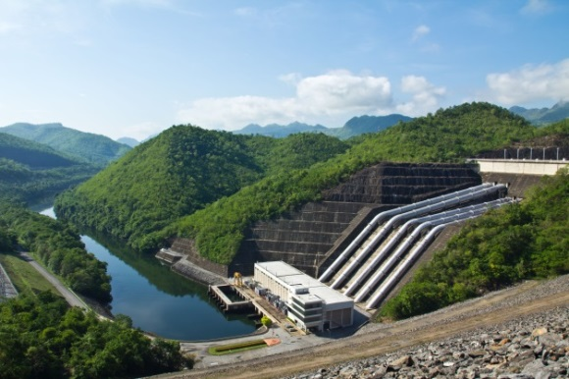
Hydro-electric power
Hydro-electricity has been used for decades as an important source of electricity. The natural force of running water turns massive turbines, which produces electricity cheaply. It is also non-polluting. However, river systems must be dammed and this affects the natural environment. Larger tracts of land are often flooded in the process, resulting in the destruction of habitats.
Photo: Amornthep Chotchuang / 123RF

Worksheet 7.5

Biosphere 2
More than three decades ago, scientists first raised concerns that the Earth was heading for an ‘ecological meltdown’. Their solution was a project known as Biosphere 2. The aim was to replicate the various ecosystems on the Earth, as well as its atmosphere, in a series of domes occupying approximately 1.3 hectares.
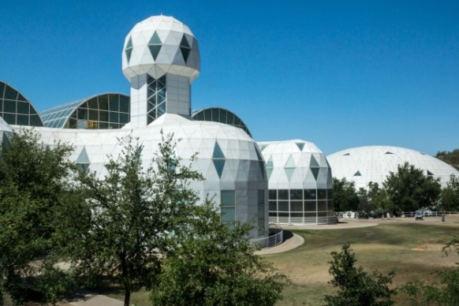
In 1991 the project reached fruition, when four men and four women took up residence within the facility for two years. The project was plagued with problems, including the collapse of ecosystems and the demise of several plant and animal species. However, a more serious problem was the inability to sustain an atmosphere; falling oxygen levels and rising carbon dioxide levels meant the project was doomed to fail without external assistance.
Perhaps what scientists really gained was an insight into our future. If we continue to rely on fossil fuels, our climate will continue to change and the atmosphere will continue to deteriorate. We will not simply be able to prop it up from another source. Alternative power sources such as hydroelectricity, wind and nuclear energy are considered sustainable, if somewhat controversial.
Photo: James Mattil / 123RF

1. Explain what is meant by the term ‘ecological meltdown’.

2. What was the aim of Biosphere 2?

3. What important lessons do you think we can learn from the Biosphere 2 project? Justify your answer.

4. Complete the following table:
 | Advantages | Disadvantages
Hydroelectricity | Cheap to produce
Wind power |  | Visually polluting
Nuclear power
5. List some of the questions you would ask an expert in these three alternative energy sources that you feel would help you decide which would be most effective in reducing global warming.

